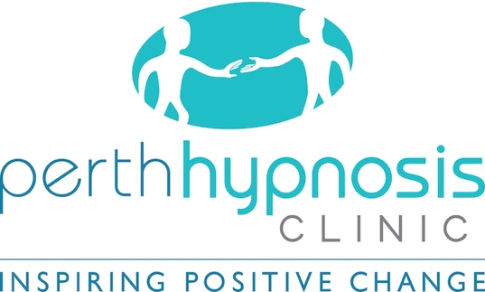

How and Why Our Hypnosis Sessions Work
We have both conscious and subconscious minds. Your conscious mind is your critical or rational mind and allows you to make yes/no decisions and responsible for those things you are consciously aware of.
The subconscious is that part of the mind that looks after everything else for you. It is the part that controls everything you do without conscious effort or thought – things that happen automatically, without thinking – blinking, laughing, crying, breathing, etc.
Your subconscious mind remembers everything you have experienced in your lifetime. All your experiences – from the time you were in the womb to this point in your life – everything you learned, everything your saw, everything you heard, everything you touched, everything you said, everything you smelt, every emotional reaction – every memory of that experience is stored in the data-bank of your subconscious mind.
That is why you don’t have to learn to tie your shoelaces every day, or to walk, to talk – everything you do automatically without thinking, and you always do those things the same way.
Your subconscious mind accesses that data-bank millions of times each day and uses the stored information to guide the mind in the way it will respond to any given stimuli. These reactions are automatic, and consciously you may not understand why you respond this way.
That is why you also respond the same way every time to the same stimuli. It is a learned behaviour. It is highly unlikely you would even remember when you first learned that response because the incident was so insignificant at the time, but over time the subconscious response became more intense because the subconscious became better at it. The same way you notice, you get better at doing something when you practice.
This is how your habits are born and grow. Any response to any stimuli is something that has been learned and practiced.
You might have felt a little peeved at something as a child, but over time something similar to that incident occurred and gradually that grew to anger. It is the same way anxiety is born. All your habits and beliefs developed the same way – from exposure and practice. You don’t even notice the development as it is so gradual.
When the stimulus occurs, the mind is still at the same age of the first response but acting with the experience of all the practice it has experienced. The negative behaviours only grow in intensity over time.
Any habits and beliefs you may have around food and exercise aren’t things you were born with. They were things you learned. Perhaps from your family or from people around you, perhaps from books or television. They’re simply things you learned.
The same way you learned laziness or to procrastinate, and it grew worse over time and became more noticeable and affected you more and more in a negative way.
The same way some use alcohol, or tobacco, or drugs – or those habits like biting nails, skin picking, grinding teeth. You weren’t born doing it – you learned it.

The process is very simple – The Simpson Protocol

You know about your conscious mind and your sub-conscious mind, but not your SUPER-conscious mind. That is the part of your mind that will mediate between your conscious and sub-conscious when we do the work.
Your mind knows how you arrived at this point, so it stands to reason that your mind knows how to resolve the issue/issues involved.
In our sessions, you will use the power of your own mind to do exactly that.
No matter what level you are hanging on to the issue – be it physical, emotional, mental or spiritual – your mind will resolve it. No matter what motive or reason your mind may have had for that unwanted behaviour – your mind will resolve it for you. All you have to do is allow your mind to do it.

I will guide you into a hypnotic trance. Now, I don’t have to teach you how to do that, because your mind already spends many times each day in trance. Every time you use your imagination, every time you daydream, every time you do something without thinking, you are in a trance state. It is a natural state. The only difference in hypnosis, is that the depth of trance is much deeper.
Hypnosis is not sleep. You will not enter a coma. You will be aware of my voice the entire session.
To help you achieve the depth of trance for hypnotherapy, I will be talking to you and asking you to follow along. It is that easy. You don’t have to do anything else – just allow your mind to follow. You do have to try to do anything. You don’t have to try not to do anything.
At a certain level of trance, I am going to ask your higher mind, or super conscious mind to keep one arm at that level and allow the rest of the body to go much deeper into trance.
We will set up your finger signals on the fingers of that arm – one for yes and one for no, as that is how I will communicate with your mind while you are in hypnosis.
We will then ask your mind to access the databank of the subconscious and all the levels of the mind, to obtain all the information it needs, to do the work you came to do.
From that point on, I will be asking your mind questions and your mind will reply with a finger signal. Depending on the answer is what I ask your mind to do for you.

I use The Simpson Protocol because it is so very efficient in helping clients resolve their issues. It allows us to leave no stone unturned so that your issues are resolved completely on all levels – mentally, emotionally, physically or spiritually – no matter where they are stored.
And it is achieved while you are in a comfortable relaxed hypnotic trance allowing you to use your own mental assets to do the evaluation and the change work within. This is a pure method of bringing about accurate change and is client-centred which empowers you.

Kenneth C Eldridge

